Lab Guide Vol4 Module 01: Hacking Wireless Networks

Scenario
Wireless networking is revolutionizing the way people work and play. A wireless local area network (WLAN) is an unbounded data communication system, based on the IEEE 802.11 standard, which uses radio frequency technology to communicate with devices and obtain data. This network frees the user from complicated and multiple wired connections. With the need for a physical connection or cable removed, individuals can use networks in new ways, and data has become ever more portable and accessible.
Although wireless networking technology is becoming increasingly popular, because of its convenience, it has many security issues, some of which do not exist in wired networks. By nature, wirelessly transferred data packets are airborne and available to anyone with the ability to intercept and decode them.
As an ethical hacker or penetration tester (hereafter, pen tester), you must have sound knowledge of wireless concepts, wireless encryption, and related threats to protect your company’s wireless network from unauthorized access and attacks. You should determine critical sources, risks, or vulnerabilities associated with your organization’s wireless network, and then check whether the current security system is able to protect the network against all possible attacks.

Objective
The objective of the lab is to protect the target wireless network from unauthorized access. To do so, you will perform various tasks that include, but are not limited to:
- Wi-Fi Packet Analysis
- Crack WPA2 Wi-Fi networks

Overview of Wireless Networking
In wireless networks, communication takes place through radio wave transmission, which usually takes place at the physical layer of the network structure. Thanks to the wireless communication revolution, fundamental changes to data networking and telecommunication are taking place. This means that you will need to know and understand several types of wireless networks. These include:
- Extension to a wired network: A wired network is extended by the introduction of access points between the wired network and wireless devices
- Multiple access points: Multiple access points connect computers wirelessly
- LAN-to-LAN wireless network: All hardware APs can interconnect with other hardware access points
- 3G/4G hotspot: A mobile device shares its cellular data wirelessly with Wi-Fi-enabled devices such as MP3 players, notebooks, tablets, cameras, PDAs, and netbooks

Lab Tasks
Ethical hackers or pen testers use numerous tools and techniques to hack target wireless networks. The recommended labs that will assist you in learning various wireless network hacking techniques include:
- Perform wireless traffic analysis
  - Wi-Fi packet analysis using Wireshark
- Perform wireless attacks
  - Crack a WPA2 network using Air crack-ng
Lab 1: Perform Wireless Traffic Analysis
Lab Scenario
As a professional ethical hacker or pen tester, your next step in hacking wireless networks is to capture and analyze the traffic of the target wireless network.
This wireless traffic analysis will help you to determine the weaknesses and vulnerable devices in the target network. In the process, you will determine the network’s broadcasted SSID, the presence of multiple access points, the possibility of recovering SSIDs, the authentication method used, WLAN encryption algorithms, etc.
The labs in this exercise demonstrate how to use various tools and techniques to capture and analyze the traffic of the target wireless network.
Lab Objectives
- Wi-Fi packet analysis using Wireshark
Overview of Wireless Traffic Analysis
Wireless traffic analysis helps in determining the appropriate strategy for a successful attack. Wi-Fi protocols are unique at Layer 2, and traffic over the air is not serialized, which makes it easy to sniff and analyze wireless packets. You can use various Wi-Fi packet-sniffing tools to capture and analyze the traffic of a target wireless network.
Task 1: Wi-Fi Packet Analysis using Wireshark
Wireshark is a network protocol sniffer and analyzer. It lets you capture and interactively browse the traffic running on a target network. Wireshark can read live data from Ethernet, Token-Ring, FDDI, serial (PPP and SLIP), and 802.11 wireless LAN. Npcap is a library that is integrated with Wireshark for complete WLAN traffic analysis, visualization, drill-down, and reporting. Wireshark can be used in monitor mode to capture wireless traffic. It can capture a vast number of managements, control, data frames, etc. and further analyze the Radio tap header fields to gather critical information such as protocols and encryption techniques used, length of the frames, MAC addresses, etc.
Here, we will use Wireshark to analyze captured Wi-Fi packets.
To capture wireless traffic, a wireless adapter is required and using an adapter in the iLab’s environment is not possible. Therefore, in this lab, we are using a sample capture file (WPA2crack-01.cap) to analyze wireless packets.
- By default, Windows 11 machine selected, click Ctrl+Alt+Delete and login with Admin/Pa$$w0rd.
Networks screen appears; click Yes to allow your PC to be discoverable by other PCs and devices on the network.
- Click windows Search icon on the Desktop; search for Wireshark in the search bar and launch it.
- The Wireshark Network Analyzer window appears.
If Software Update window appears, click Skip this version to close it.
- In the menu bar, click File and click Open option from the drop-down list.
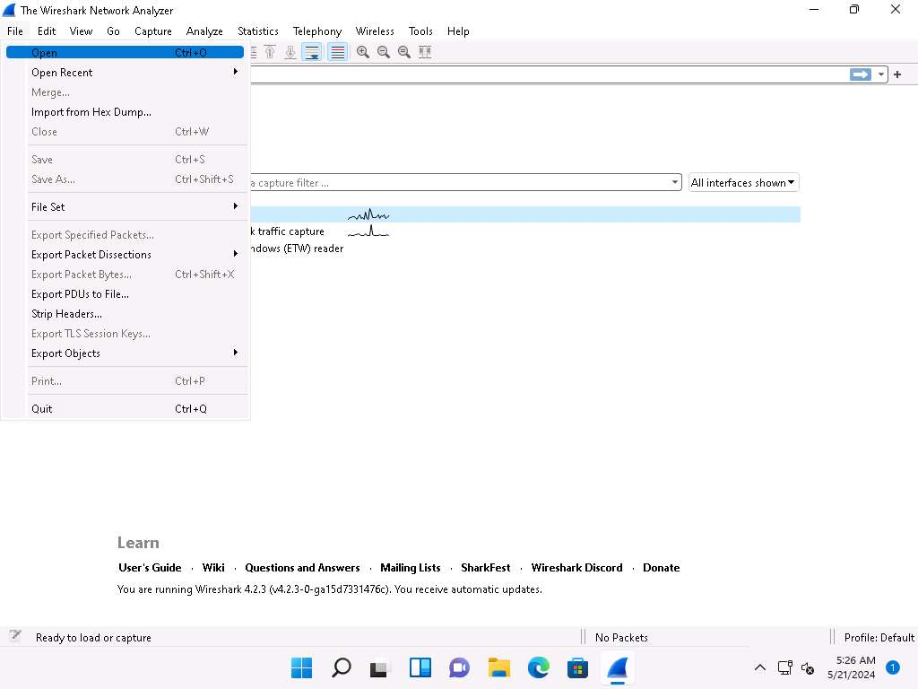
- Wireshark: Open Capture File window appears; navigate to E:\CEH-Tools\CEHv13 Module 16 Hacking Wireless Networks\Sample Captures, select WPA2crack-01.cap and click Open.
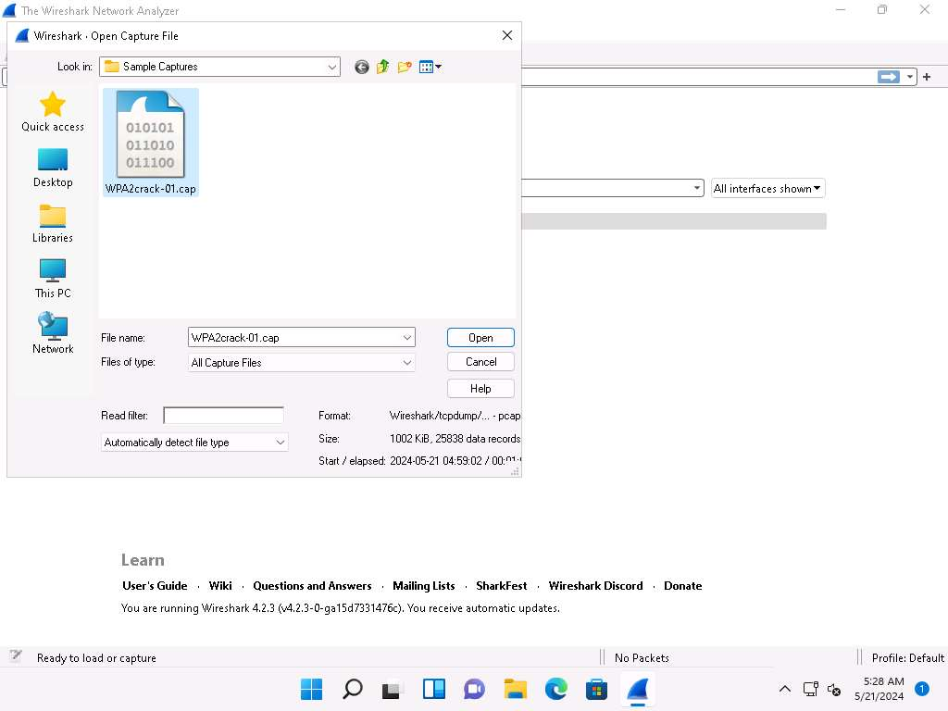
- The WPA2crack-01.cap file opens in Wireshark window showing you the details of the packet for analysis. Here you can see the wireless packets captured which were otherwise masked to look like ethernet traffic.
Here 802.11 protocol indicates wireless packets.
You can access the saved packet capture file anytime, and by issuing packet filtering commands in the Filter field, you can narrow down the packet search to find packets containing sensible information.
In real time, attackers enforce packet capture and packet filtering techniques to capture packets containing passwords (only for websites implemented on HTTP channel), perform attacks such as session hijacking, and so on.
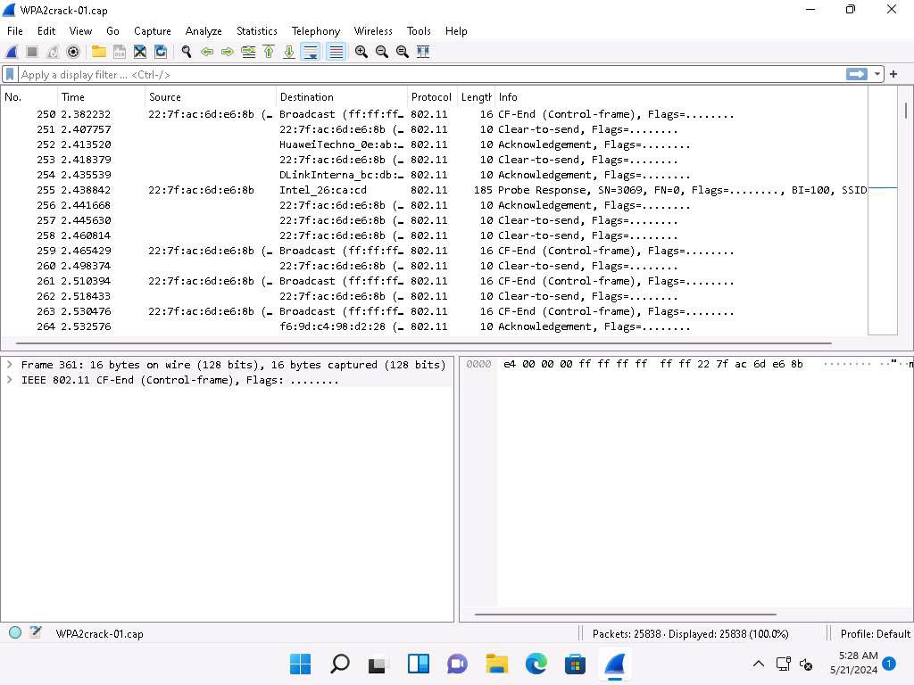
- This concludes the demonstration of how to analyze Wi-Fi packets using Wireshark.
- Close all open windows and document all the acquired information.
- You can also use other wireless traffic analyzers such as AirMagnet WiFi Analyzer PRO (https://www.netally.com), SteelCentral Packet Analyzer (https://www.riverbed.com), Omnipeek Network Protocol Analyzer (https://www.liveaction.com), and CommView for Wi-Fi (https://www.tamos.com) to analyze Wi-Fi traffic.
Question 16.1.1.1
Use the Wi-Fi packet-sniffing tool Wireshark to analyze captured Wi-Fi packets (WPA2crack-01.cap). Enter the protocol that indicates the wireless packets. Note: sample captured Wi-Fi packets are available at E:\CEH-Tools\CEHv13 Module 16 Hacking Wireless Networks\Sample Captures.
Lab 2: Perform Wireless Attacks
Lab Scenario
As an expert ethical hacker or pen tester, you must have the required knowledge to perform wireless attacks in order to test the target network’s security infrastructure.
After performing the discovery, mapping, and analysis of the target wireless network, you have gathered enough information to launch an attack. You should now carry out various types of attacks on the target network, including Wi-Fi encryption cracking (WPA2), fragmentation, MAC spoofing, DoS, and ARP poisoning attacks.
As an ethical hacker and pen tester of an organization, you must test its wireless security, exploit WPA2 flaws, and crack the network’s access point keys.
The labs in this exercise demonstrate how to perform wireless attacks using various hacking tools and techniques.
Lab Objectives
- Crack a WPA2 network using Aircrack-ng
Overview of Wireless Attacks
There are several different types of Wi-Fi attacks that attackers use to eavesdrop on wireless network connections in order to obtain sensitive information such as passwords, banking credentials, and medical records, as well as to spread malware.
These include:
- Fragmentation attack: When successful, such attacks can obtain 1,500 bytes of PRGA (pseudo random generation algorithm)
- MAC spoofing attack: The attacker changes their MAC address to that of an authenticated user in order to bypass the access point’s MAC-filtering configuration
- Disassociation attack: The attacker makes the victim unavailable to other wireless devices by destroying the connectivity between the access point and client
- Deauthentication attack: The attacker floods station(s) with forged deauthentication packets to disconnect users from an access point
- Man-in-the-middle attack: An active Internet attack in which the attacker attempts to intercept, read, or alter information between two computers
- Wireless ARP poisoning attack: An attack technique that exploits the lack of a verification mechanism in the ARP protocol by corrupting the ARP cache maintained by the OS in order to associate the attacker’s MAC address with the target host
- Rogue access points: Wireless access points that an attacker installs on a network without authorization and that are not under the management of the network administrator
- Evil twin: A fraudulent wireless access point that pretends to be a legitimate access point by imitating another network name
- Wi-Jacking attack: A method used by attackers to gain access to an enormous number of wireless networks
Task 1: Crack a WPA2 Network using Aircrack-ng
WPA2 is an upgrade to WPA; it includes mandatory support for Counter Mode with Cipher Block Chaining Message Authentication Code Protocol (CCMP), an AES-based encryption protocol with strong security. WPA2 has two modes of operation: WPA2-Personal and WPA2-Enterprise. Despite being stronger than both WEP and WPA, the WPA2 encryption method can also be cracked using various techniques and tools.
In this task, we will use the Aircrack-ng suite to crack a WPA2 network.
Before starting this task, you need to configure your access point router (ECC Labs) to work in WPA2-PSK (Pre-Shared Key) encryption mode. To do so, navigate to the router’s default IP address and change the authentication mode to WPA2-PSK, with the password as 12345678.
In order to capture wireless traffic, a wireless adapter is required and using an adapter in the iLabs environment is not possible, therefore, in this lab, we are using a sample capture file (WPA2crack-01.cap) to crack WPA key.
- Click Parrot Security to switch to the Parrot Security machine and login with attacker/toor.
- Navigate to the Places in the top-section of the window and click Desktop from the drop-down list.
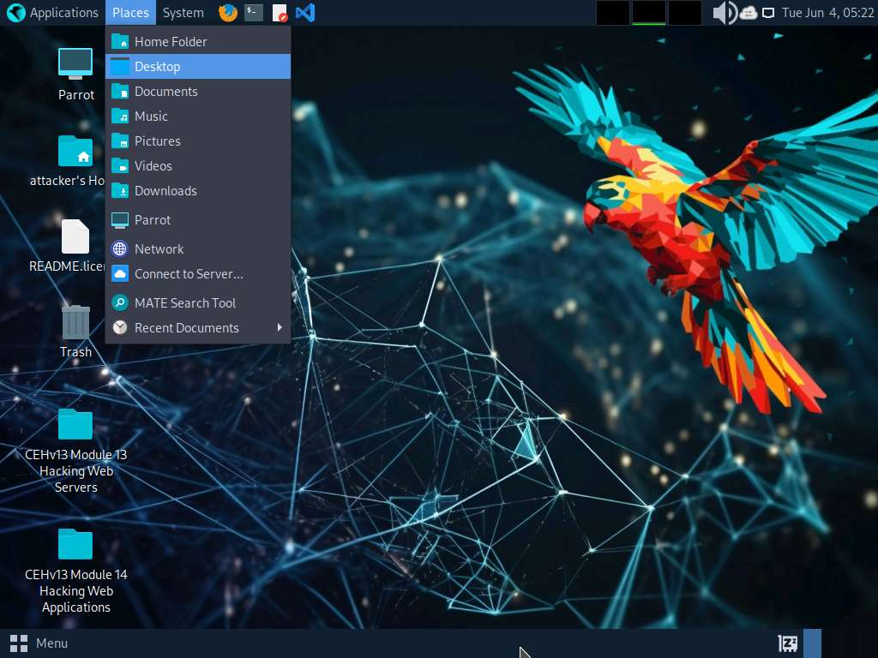
- The Desktop window appears; navigate to the CEHv12 Module 16 Hacking Wireless Networks folder and copy Sample Captures and Wordlist folders.
To copy the folders, firstly select both the folders and then press Ctrl+C.
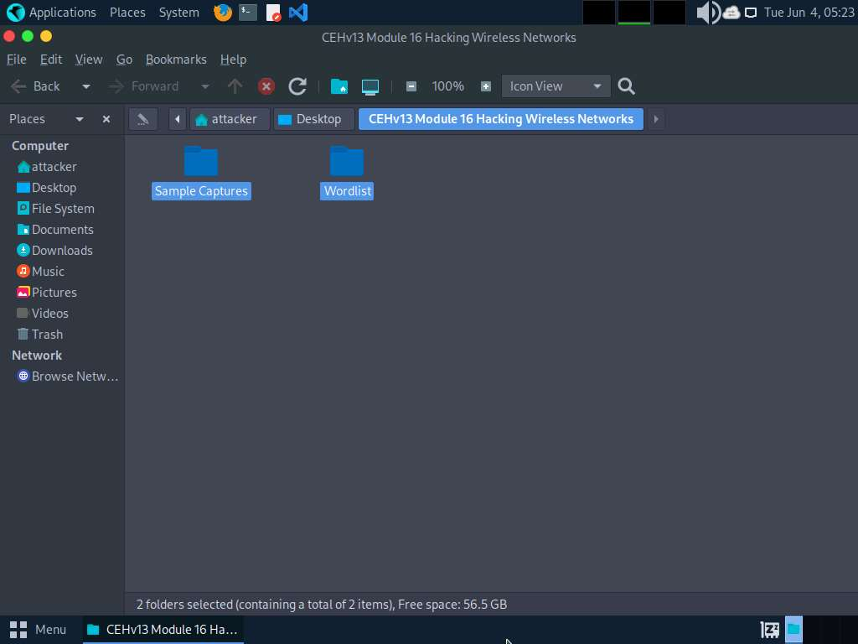
- Now, navigate to the Desktop and press Ctrl+V to paste the copied folders (Sample Captures and Wordlist). Close the Desktop window.
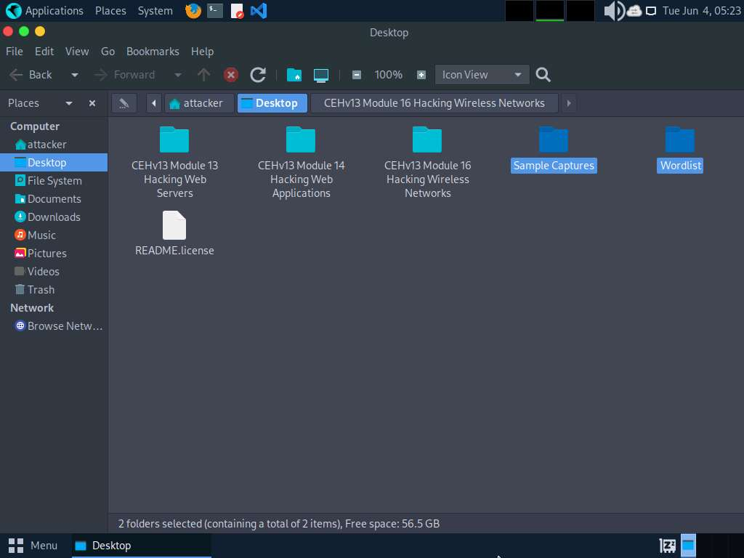
- Open a Terminal window and execute sudo su to run the programs as a root user (When prompted, enter the password toor).
- In the Parrot Terminal window, run aircrack-ng -a2 -b [Target BSSID] -w /home/attacker/Desktop/Wordlist/password.txt '/home/attacker/Desktop/Sample Captures/WPA2crack-01.cap'. Here, the BSSID of the target is 22:7F:AC:6D:E6:8B.
  - -a is the technique used to crack the handshake, 2=WPA technique.
  - -b refers to bssid; replace with the BSSID of the target router.
  - -w stands for wordlist; provide the path to a wordlist.
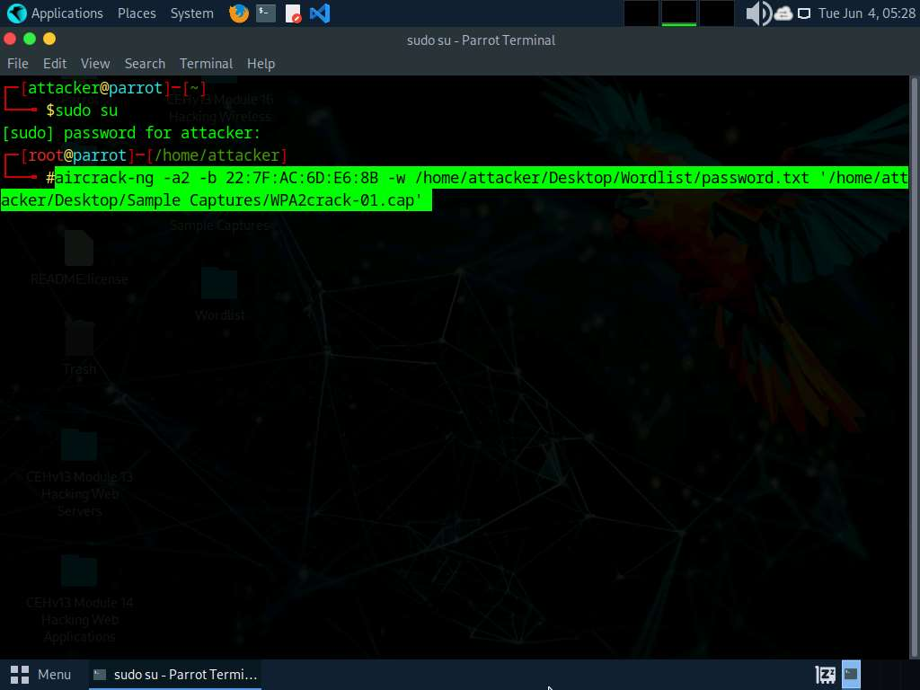
- The result appears, showing the WPA handshake packet captured with airodump-ng. The target access point’s password is cracked and displayed in plain text next to the message KEY FOUND!, as shown in the screenshot.
If the password is complex, aircrack-ng will take a long time to crack it.
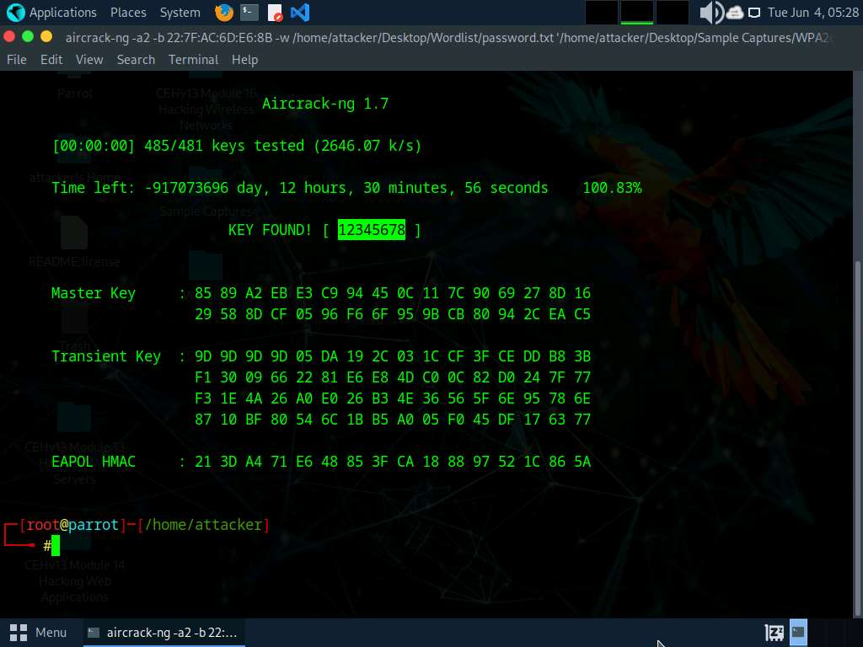
- This concludes the demonstration of how to crack a WPA2 network using Aircrack-ng.
- Close all open windows and document all the acquired information.
- You can also use other tools such as hashcat (https://hashcat.net), Portable Penetrator (https://www.secpoint.com), WepCrackGui (https://sourceforge.net) to crack WEP/WPA/WPA2 encryption.
Question 16.2.1.1
Use the Aircrack-ng suite to crack a WPA2 network. Enter the key found in this exercise. Note: sample captured Wi-Fi packets and wordlist are available at /home/attacker/Desktop/CEHv13 Module 16 Hacking Wireless Networks

